Vision Document
This Vision outlines the desired business outcome, context, problem and vision for your new project idea. The following questions will guide technical teams in providing ball-park T Shirt sizing for the proposal. If unsure, provide your best first draft — your Business Engagement Mobilisation Partner will help you refine this after submission.

Business Area | ☒ Wholesale Mobile & MW (O2 Daisy)  ☐ Wholesale Fixed Connectivity  ☐ B2B IT Migration
Initiative Name | Apple Device Enrolment
Sponsor Name | Mike Pratt / Dav Sandher
Product Owner Name | Neil Hodson / Yiannis Niarchos
O2 Daisy ID | ID340
O2Daisy CTIO Approved | Yes – approved with Lyndsey Charlton.
O2Daisy IT Architecture design or context | Aligned to plan

NDA required? | No | NDA admin | N/A
Aspirational start date | 20/4/26 | Aspirational delivery date | 1/9/2026

Commercial launch date | Phased delivery considerations/needs | Drivers
1/7/2026 | Requesting delivery before SME/So migration in July and Apple’s NPI in September. | This will enable the development of a scalable process with no manual interventions and facilitate trading during the peak Apple NPI period.

Vision Document Summary

The Vision Document serves as a key foundation for any business initiative. It outlines the core problem, objectives, expected benefits, scope, and identifies associated risks, assumptions, and dependencies. Its purpose is to provide a clear and comprehensive overview that supports accurate impact assessment and informed planning.

This document is a required input for the Ideate Pack, which is used by the Mobile & MW Portfolio pod team to evaluate the initiative across all relevant touchpoints. A well-prepared Vision Document ensures the Ideate Pack can be completed accurately and effectively.

Table of Contents
1. Background / Problem & Opportunity / Scope Summary 2
2. In Scope (Required) 3
3. Customer Journey Touch Points (Required) 6
4. Out of Scope (Required) 7
5. Legal/Regulatory, Fraud, Security and environmental impacts 8
6. Dependencies / Risks / Assumptions [Required] 9
7. Approvals & Document Control [Internal Delivery Team] 10
8. Appendices 10

Background / Problem & Opportunity / Scope Summary

1.1 Background
Where does the problem or opportunity occur? What is the context, event, or customer journey in which it occurs?

Context/Background
- Schedule 7 requires all devices to be purchased through VMO2, with a TSA compliance deadline of 30 April 2026.
- O2 Daisy Transformation has produced a high-level architecture, but VMO2 and O2 Daisy are unable to meet the TSA deadline.
- We are currently operating a dual-warehouse model: GXO for f-VMO2 orders and Westcoast for f-Daisy orders: To comply with our contractual agreements, we are shipping devices to Westcoast via the indirect DISE process so they can fulfil all Daisy orders.
- The fulfilment of Apple DEP-enrolled devices currently requires manual intervention, as there is no automated process in place within the Daisy/Westcoast environment.
- This request aims to eliminate the need for duplicate and manual Apple device enrolment processes until full integration with GXO is achieved (refer to request IDs 377 and 378).

Current State Process

- Current Fulfilment Model

Path 1: DISE (Established / BAU)

Individual customer orders only for Apple devices, where customers require DEP enrolment.
Daisy places via partner portal → DISE → GXO. GXO fulfils orders directly to the customer.
Includes:
- Automated fulfilment
- Apple enrolment processes (via existing integration)
- This flow is working and not being changed

Path 2: Daisy Central (Interim / Workaround)

Individual customer orders for all devices:
- Apple: customers don’t require DEP enrolment Orders placed in Daisy Central → fulfilled from West Coast warehouse
- All other devices including Samsung whether customer requires enrolment or not.

Stock is: Shipped from GXO → West Coast to support this model

Current problems:
- No integration to GXO fulfilment processes
- No automated Apple enrolment
- Requires multiple manual interventions

- Dual Ordering Process (Critical Behaviour)

Current logic:
Non-enrolled devices:
- Ordered via Daisy Central
- Fulfilled from West Coast stock (ordered in bulk in advance from VMO2)
Apple enrolled devices
- Cannot be fulfilled from West Coast

Must be:
- Re-keyed manually into Indirect Portal
- Routed to DISE → GXO
- Fulfilled from GXO via the existing enrolment process.

This creates:
- Duplicate order handling
- Inconsistent fulfilment paths

- Pain points - Manual Operational Activities

The interim model requires:
- Forecasting & Stock Movement
  - Manual forecasting and bulk ordering via GXO
  - Devices shipped to West Coast manually

- Apple Enrolment Workaround
  - Manual re-entry of orders via indirect portal
  - To trigger enrolment via DICE integration

- Post-Fulfilment Handling
  - Additional manual steps required
  - Load enrolled devices into Daisy Central
  - Enable downstream build/billing

- Resourcing
  - Manual process supported by ~3 people

- Scaling Risk

- More customers are being moved to Daisy Central
- Manual workload will:
- Increase significantly
- Potentially block transformation progress

Illustration of all three current processes and high-level changes

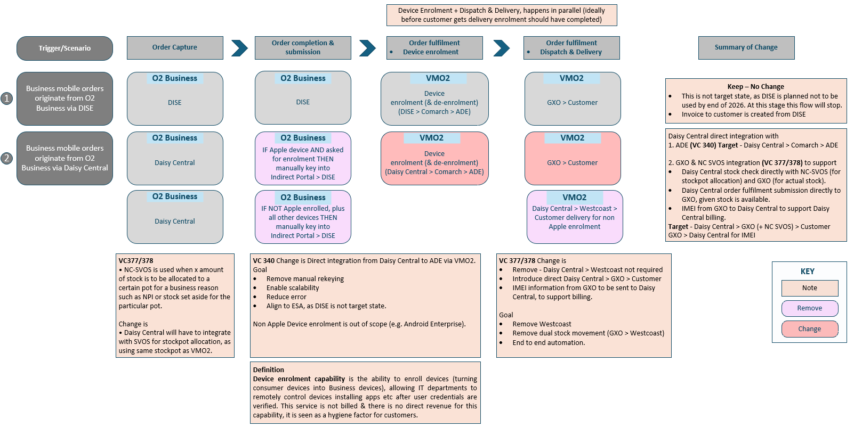
1.2 Problem & Opportunity
State the main problem(s) and the opportunity created by addressing them. Highlight key pain points and expected benefits

Problem

- Manual and duplicate processes are used to enrol and de-enrol Apple devices as separate per-customer orders are raised into the indirect portal for individual shipping.
- The existing manual Apple DEP enrolment process is not scalable, which prevents the transformation from migrating any significant number of SME and Soho customers to Daisy Central.
- The existing Apple Device Enrolment process relies on DISE and Westcoast‑specific routing, which is not fully aligned with Daisy Central as the future system of record.
- IMEI data will be available in Daisy Central, but the end‑to‑end automated feed into SRM is not yet fully established or approved within current CIO timescales.
- O2 Daisy faces tight delivery timelines, and waiting for full assessment, build and approval risks delaying Apple device fulfilment for customers.
- Any short‑term solution must continue to meet security, compliance and audit requirements, and must not introduce risk, rework or long‑term technical debt.

Opportunity

- SRM (Comarch) has confirmed that where the file structure and outputs remain unchanged, existing Apple enrolment integrations can continue without redesign.
- A phased approach enables:
  - An interim manual workaround to protect near‑term delivery, and
  - A strategic move to an automated Daisy Central → SRM feed as the steady‑state solution.
- This allows O2 Daisy to maintain customer experience and Apple compliance without blocking on governance timelines, while still converging on the target architecture.
- The approach is considered a small, low‑risk change for O2 Daisy, with SRM estimating 2–4 weeks of effort for testing once the automated feed is ready.

- What O2 Business is asking for:

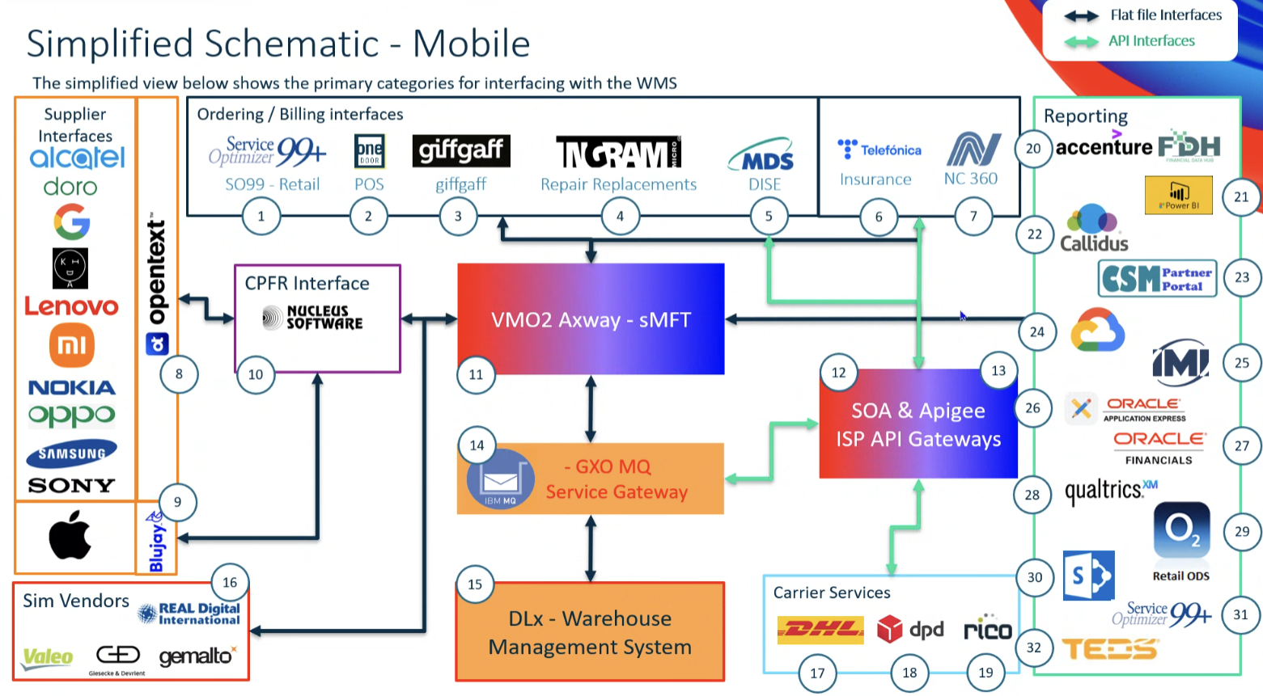
1.3 Scope Summary
Summarise what is included and excluded from the initiative to set clear expectations and boundaries
In Scope (MVP / Phased Delivery)
Phase 1 – Interim Workaround (Time￼Bound)

Primary Ask (Immediate Priority)
Automate Apple Device Enrolment from Daisy Central. Specifically:
- Enable:
  - Orders from Daisy Central to trigger enrolment
- Avoid:
  - Manual rekeying into DISE / indirect portal
We also require support from VMO2/Comarch to determine the following elements of the device enrolment build in Daisy Central:
- Location and credentials to store the enrolment files when built
- The enrolment file data attributes and values where those values are system / process driven.

- The workaround is explicitly:
  - Temporary,
  - Volume controlled, and
  - Subject to defined operational ownership to avoid bottlenecks.

Business Benefits
- Lower effort than full integration
- Deliverable earlier
- Critical to remove manual steps
- No more rekeying orders into the indirect portal
- Eliminates duplication for Apple enrolment

1.4 Business Outcomes
Describe the business outcomes for this project. (A business outcome describes the measurable change in business performance or behaviour that will be delivered if this initiative is successful.)

- Reduced manual intervention and process duplication, minimising the risk of human error while improving resource efficiency and capacity.
- Operational scalability through automation: elimination of fragmented manual processes and establishment of a repeatable operating model that supports future growth and strategic API-led integration.
- Improved customer service speed, enabling faster fulfilment and shorter delivery cycles. Faster order handling for enrolled devices.
- Optimised returns and de-enrolment processes, delivering a streamlined and consistent end-to-end fulfilment experience.
- Lower error rates in enrolment
- Removes critical blocker to scaling

In Scope

Area | Impacted
Channels | ☐ No Channel Impact (BAU)  ☐ Assisted (e.g. Contact Centre, Field Sales)  ☐ Unassisted (e.g. Self-Service)  ☒ Change to Existing eCommerce  ☐ New eCommerce Channel  ☐ Stores  ☐ Other (Specify)
Customer Segment | ☐ Wholesale Fixed  ___________________________________________________  ☐ Wholesale Mobile  ☒ SMB Direct  ☐ SMB Indirect  ☐ Volume Sales  ☒ Large Enterprise  ☒ Public Sector  ☒ Soho Direct  ☐ Soho Indirect  ☐ WHS O2 Daisy (ABS SPID 372)  ☐ VIP  ☒ O2 Daisy BUD  ___________________________________________________  ☐ Other (Specify)
Customer Type | ☒ New Customer ☒ Existing Customer
Order Type | ☒ New Order - New Customer  ☒ New Order - Existing Customer  ☐ Renewal/Resign Order - Existing Customer  ☐ Additional Connection Order - Existing Customer  ☐ MACD - Existing Customer  ☐ Other (Specify)
API Required | Impact: ☐ Yes ☒ No ☐ Unknown  If Yes - which APIs are expected to be delivered by VMO2 as part of the requirement?
Logistics / Supply Chain | Impact: ☐ Yes ☒ No ☐ Unknown  If Yes: Please specify the details.
Reporting | Impact: ☒ Yes ☐ No ☐ Unknown  If Yes – Please outline the requirements and describe the type of impact e.g.  ☐ New Reports  ☒ Amend/Update Existing Reports
Migration Requirements | Impact: ☐ Yes ☒ No ☐ Unknown  If Yes: Please specify the details.
Decommissioning Requirements | Impact: ☐ Yes ☒ No ☐ Unknown  If Yes: Please specify the details.
Cease Existing Service/Supplier | Impact: ☐ Yes ☒ No ☐ Unknown  If Yes: Please specify the details.
Network or IT Operations Impact | Impact: ☐ Yes ☒ No ☐ Unknown  If Yes: Please specify the details: Please see Appendix and below.
RFI/P | Impact: ☐ Yes ☒ No ☐ Unknown  If Yes: Please specify the details.
Known Constraints | Impact: ☐ Yes ☒ No ☐ Unknown  If Yes: Please specify the details.  Apple Watch doesn’t support QR code eSIM
Other | Impact: ☐ Yes ☒ No ☐ Unknown  If Yes: Please specify the details.

Customer Journey Touch Points (Required)

The customer journey is broken down into key touch points that represent different stages of interaction with our products or services from discovery to potential exit. Each touch point reflects a critical moment in the customer experience.

Please review the touch points below and indicate which ones are impacted by your initiative, along with a brief description of the nature of the impact (e.g., improvement, change, risk, etc.).

We Discover – Customers explore and learn about products or services | Impacted ☐ Yes ☒ No ☐ Unknown
We Buy – Customers / Sales people select and purchase a product or service | Impacted ☐ Yes ☒ No ☐ Unknown  If Yes - please outline any specific requirements:  If Yes – confirm solution impact if known  Wholesale Mobile  ☐ Blue Salesforce  ☐ Purple Salesforce / CPQ  ☐ Microsoft Dynamics 365  ☐ Other (Specify)  - Daisy Central (SMB / SoHo)  - Daisy central (LE/PS)  - Strategic architecture TBC  - Solution needs to integrate into O2 Daisy BSS  Wholesale Fixed  ☐ Red Salesforce  ☐ Engage  ☐ BPT  ☐ Other (Specify)
We Join / Onboard – Product/service is delivered, set up, and activated | Impacted ☒ Yes ☐ No ☐ Unknown  If Yes - please outline any specific requirements:  If Yes – confirm solution impact if known  Wholesale Mobile  ☒ O2 Daisy only  ☐ DISE only  ☐ DISE & O2 Daisy  ☒ Other (Specify)  - Daisy Central (SMB / SoHo)  - Solution needs to integrate into O2 Daisy BSS  Wholesale Fixed  ☐ DISE  ☐ Force  ☐ Oracle  ☐ Other (Specify)
We Use – Customers experience the service, including issue resolution. | Impacted ☐ Yes ☒ No ☐ Unknown  If Yes - please outline any specific requirements:
We Manage Billing – Customers view and manage bills and usage | Impacted ☐ Yes ☒ No ☐ Unknown  If Yes - please outline any specific requirements:  If Yes – confirm solution impact if known  Wholesale Mobile  ☒ O2 Daisy only  ☐ DISE only  ☐ DISE & O2 Daisy  ☒ Other (Specify)  Wholesale Fixed  ☐ DISE  ☐ NRM  ☐ Oracle  ☐ Other (Specify)
We Add / Change – Customers modify or upgrade their services | Impacted ☐ Yes ☒ No ☐ Unknown  If Yes - please outline any specific requirements:  Customers can add / remove Watch services ‘in life’ via Service Desk.
We Stay or Leave – Customers decide to renew, stay, or exit | Impacted ☐ Yes ☒ No ☐ Unknown  If Yes - please outline any specific requirement:  Customers will need to be able to re-sign / retain the Watch subscriptions at point of contract re-sign.

Out of Scope (Required)

Out of Scope Item | Future Scope (e.g. later phase Delivery)
1 BAU DISE Process
Existing:
Partner Portal → DISE → GXO flow
2 Bulk Device Ordering Process
Ordering via partner portal into DISE remains
Bulk stock flow:
GXO → West Coast remains for interim
3 Procurement / Supply Chain BAU
Device procurement via supply chain: Remains unchanged
Considered: Separate from enrolment solution scope
Changes to Apple enrolment policies, customer configurations or Apple commercial arrangements.
Redesign or decommissioning of DISE outside this specific Apple Device Enrolment flow.
Permanent reliance on manual processes beyond the agreed interim period.
Any workaround that bypasses agreed security, compliance, or audit controls.

Legal/Regulatory, Fraud, Security and environmental impacts
If this requirement is impacted by or changes our capability to maintain legal, fraud, security or environmental obligations then add details here.

Area | Impact | VMO2 stakeholder
Legal / contractual / legislative obligations | ☐ Yes ☒ No ☐ Unknown
Regulatory obligations e.g. OFCOM, ICO, etc. | ☐ Yes ☒ No ☐ Unknown
Fraud or Security Impact | ☐ Yes ☒ No ☐ Unknown
Has the whole environmental impact of the project, from design to end of life been considered? | ☐ Yes ☒ No ☐ Unknown
Has the lowest energy using product or service been considered for the project (if applicable)? | ☒ Yes ☐ No ☐ Unknown | More devices will ship directly to the customer from GXO avoiding the double handling (GXO → Westcoast → Customer)
Equity / Accessibility of VMO2 service(s) | ☐ Yes ☒ No ☐ Unknown

Dependencies / Risks / Assumptions [Required]

Dependencies
List any decisions, actions or projects that are required for this proposal to proceed (inbound) or required by other projects (outbound).

Dependencies raised
- Architecture alignment required
- Potential need to validate with:
  - Supply chain
  - Apple relationship owners

ID | Inbound or Outbound | Project reference (if any) | Description/nature of dependency
D3 | Outbound | IDs 377 & 378  Supply Chain ID 11047025174 | 377 & 378: O2 Daisy Warehouse Interfacing (Tactical – Flat Files) & (Strategic - API) - Is this a dependency on the this interim ask?

Risks
Please list any risks (events that could happen, but have not happened yet), that would impact cost / scope / timelines / successful delivery.

ID | Risk Description | Probability | Impact if this happens
R1 | More customers are being moved to Daisy Central, so the manual workload will:  - Increase significantly  - Potentially block transformation progress
R2

Assumptions
Please list key assumptions that remain to be validated to establish if the vision / benefits can be delivered.

ID | Assumption Description
A1 | GXO and RDi remain the only logistics partners of VMO2 supply chain
A2 | IT transformation schedule and timelines of customers migration

Approvals & Document Control [Internal Delivery Team]
.
Name | Role | Approval (signature or email) | Date
 | Sponsor / Delegate
 | Product Manager / Owner Requestor
Portfolio Leads SBA, PM, SSA
(Scope is fit for purpose and relevant stakeholders have been consulted or informed)

Author | Version | Date | Reason
R. Munir | 0.1 | 17/4/2026 | First draft
Y. Niarchos | 0.2 | 18/5/2026 | First review with stakeholders
 | 1.0 |  | Approved Version

Appendices

Customers increasingly expect Apple devices to be delivered pre‑configured, secure and ready for use, particularly where Apple Device Enrolment (ADE) is required to apply device management and security policies prior to first use.

Today, Apple device enrolment is triggered once devices are procured, using IMEI data from the supply chain. Requests are processed through DISE, supported by Westcoast as an intermediary platform, before being passed to SRM, which converts validated enrolment files into API requests to Apple. This flow is proven but tightly coupled to legacy DISE‑centric integrations.

As part of O2 Daisy’s ongoing operating model simplification and the move towards Daisy Central as the primary orchestration platform, IMEI data will now be received from Westcoast directly into Daisy Central. However, the downstream Apple Device Enrolment process must continue to function without disruption, while aligning incrementally to the target architecture.

Given current CIO governance timelines (6–8 weeks) and de‑prioritisation of some supporting initiatives, a pragmatic, time‑bound interim approach is required to prevent delivery delays for O2 Daisy customers.

Out of Scope (for this Initiative)

- Changes to Apple enrolment policies, customer configurations or Apple commercial arrangements.
- Permanent reliance on manual processes beyond the agreed interim period.
- Redesign or decommissioning of DISE outside this specific Apple Device Enrolment flow.
- Any workaround that bypasses agreed security, compliance, or audit controls.

Out of scope

1 BAU DISE Process
Existing:
Partner Portal → DISE → GXO flow

2 Bulk Device Ordering Process
Ordering via partner portal into DISE remains
Bulk stock flow:
GXO → West Coast remains for interim

3 Procurement / Supply Chain BAU
Device procurement via supply chain: Remains unchanged
Considered: Separate from enrolment solution scope

Suggested approach discussed:
- Daisy Central to generate:
- An enrolment file in required format.
- Join existing MDS → Comarch → Apple processing stream
- IMEI data received from Westcoast into Daisy Central.
- Manual generation of the Apple enrolment and de-enrolment file from Daisy Central.
- Secure manual email transfer of the enrolment and de-enrolment file to SRM using agreed secure distribution lists and controls.
- SRM continues to:
  - Validate the file,
  - Convert it into API requests, and
  - Submit enrolment requests to Apple with no change to Apple integrations.

